**K214503**

**Muhammad Tahir**

**Quiz 01**

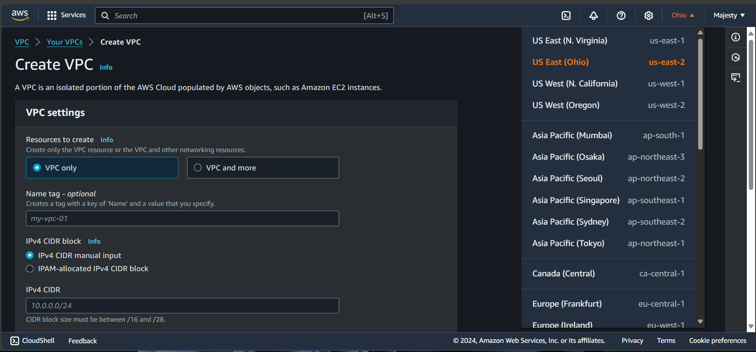

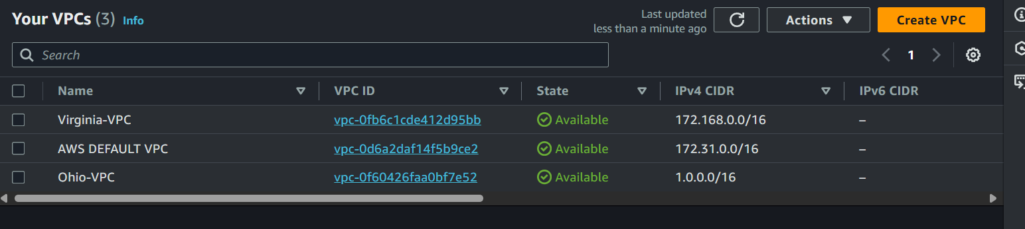

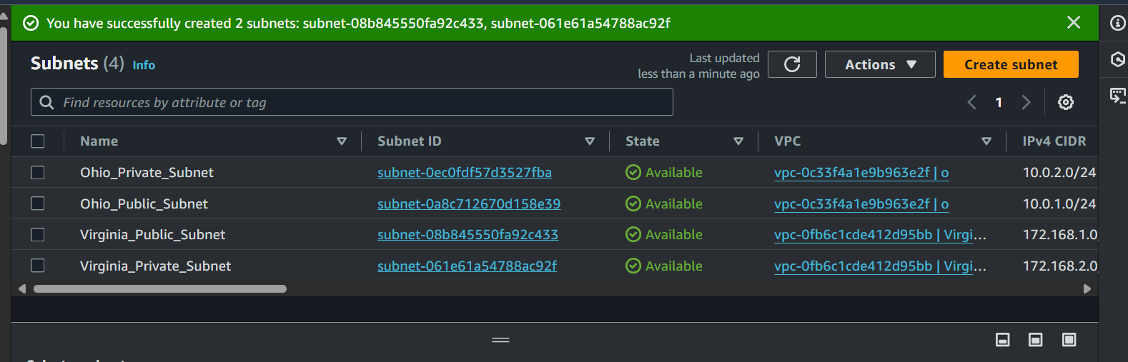

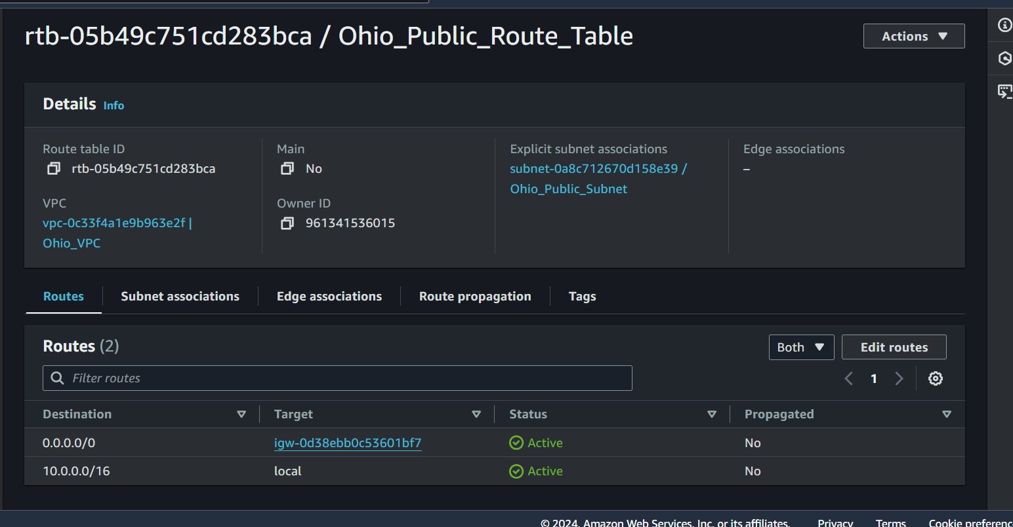

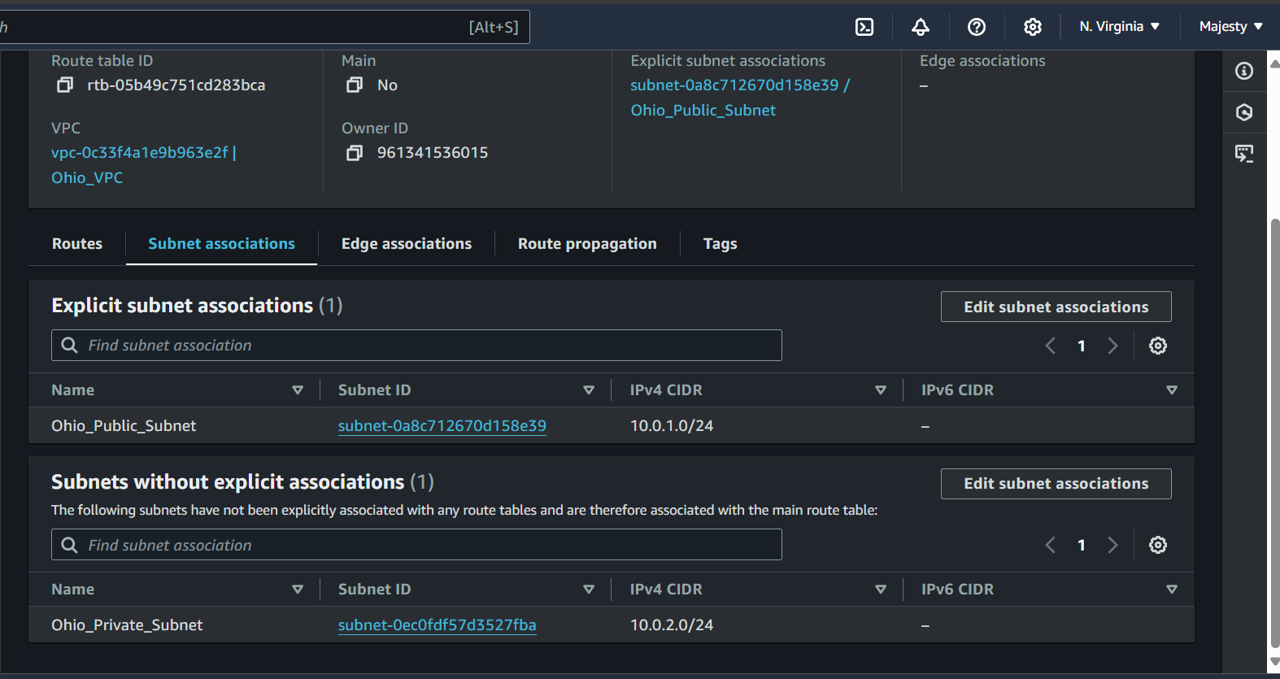

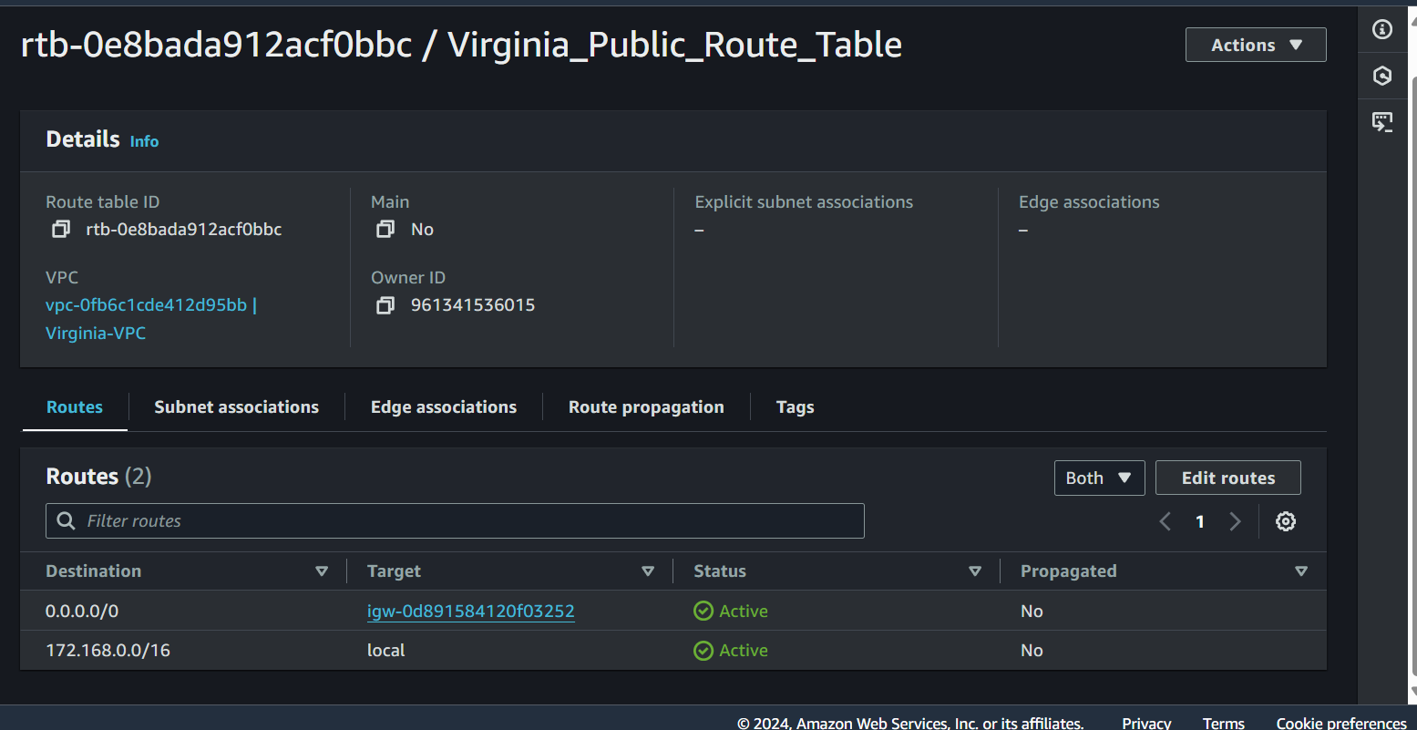

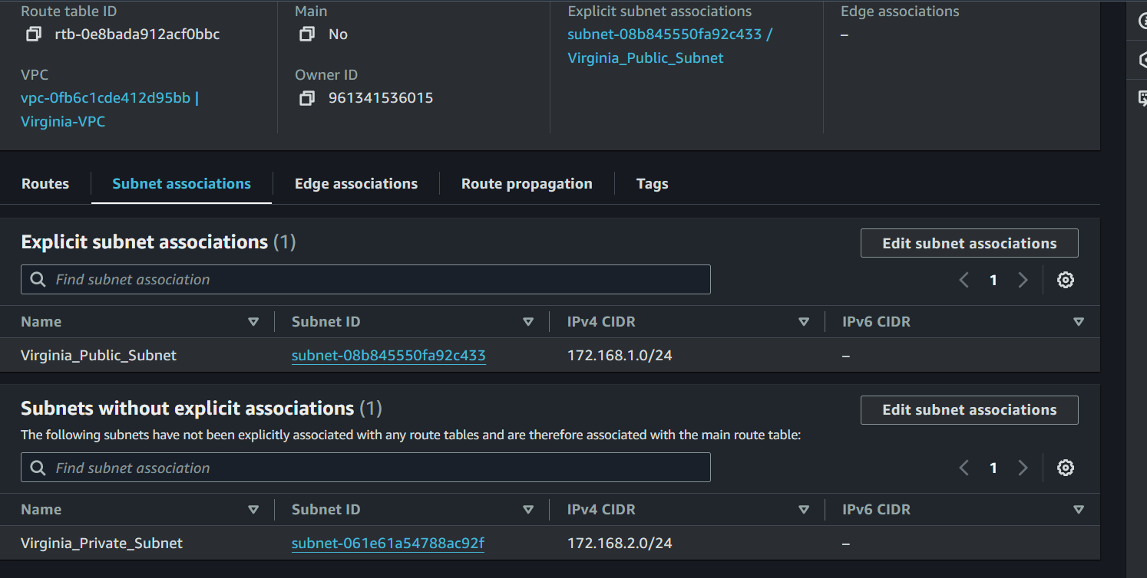

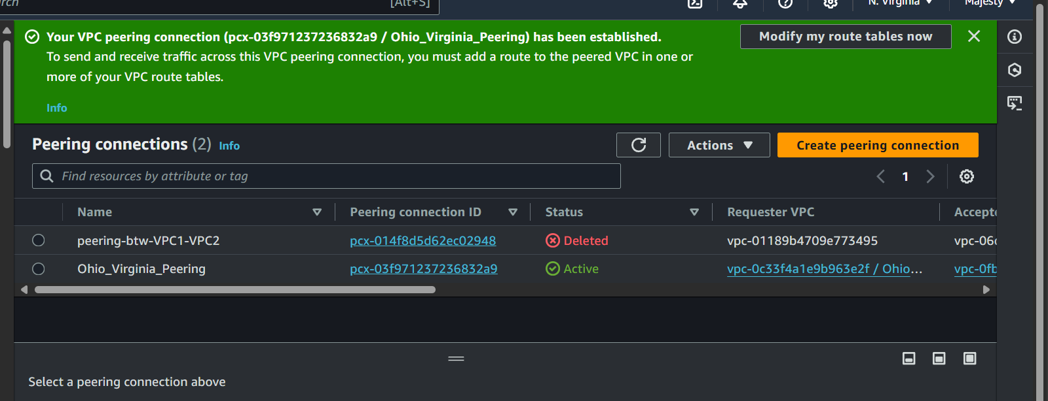

Public route table of Virginia  
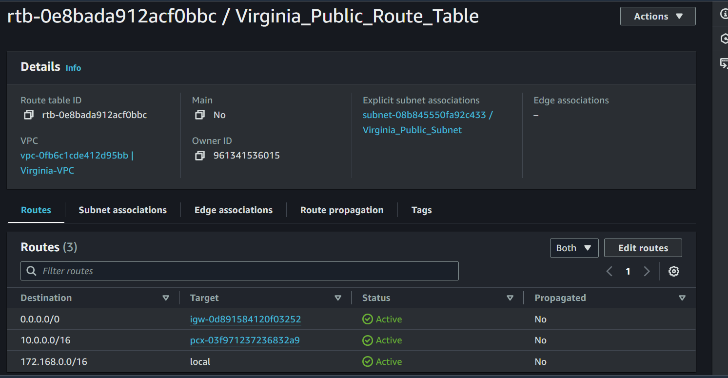  
  
private route table of Ohio  
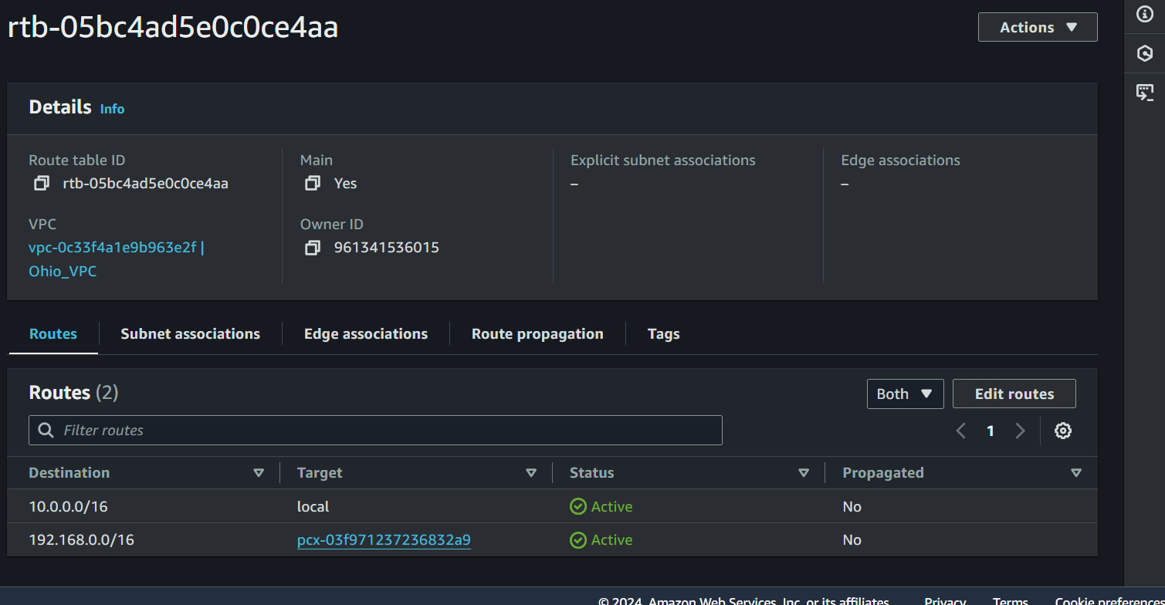

Ohio VPC

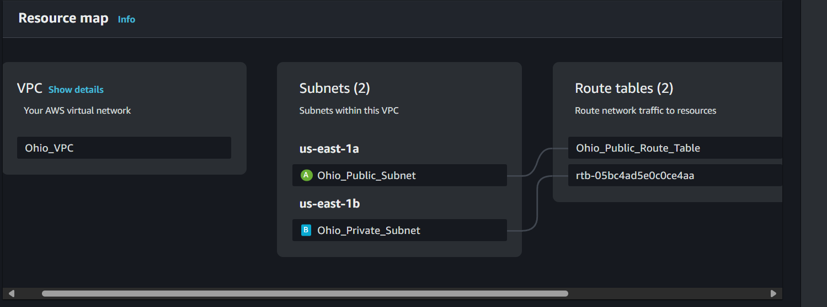

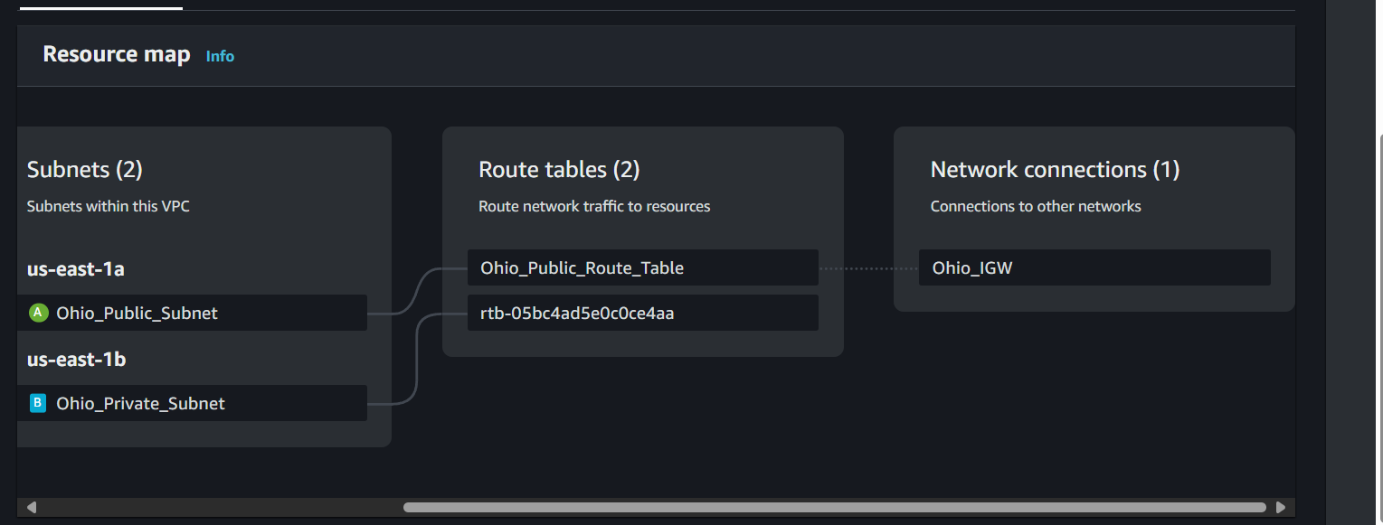

Virginia VPC:  
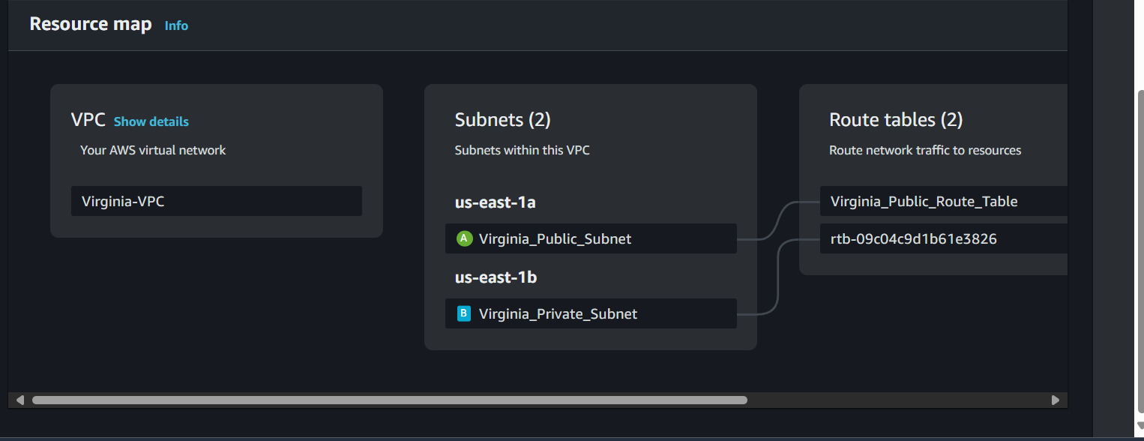

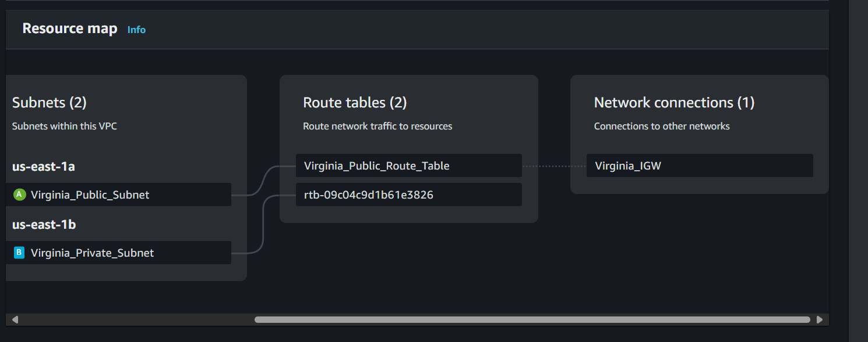

Accessed the windown and then from there accessed the Linux which is in Private subnet

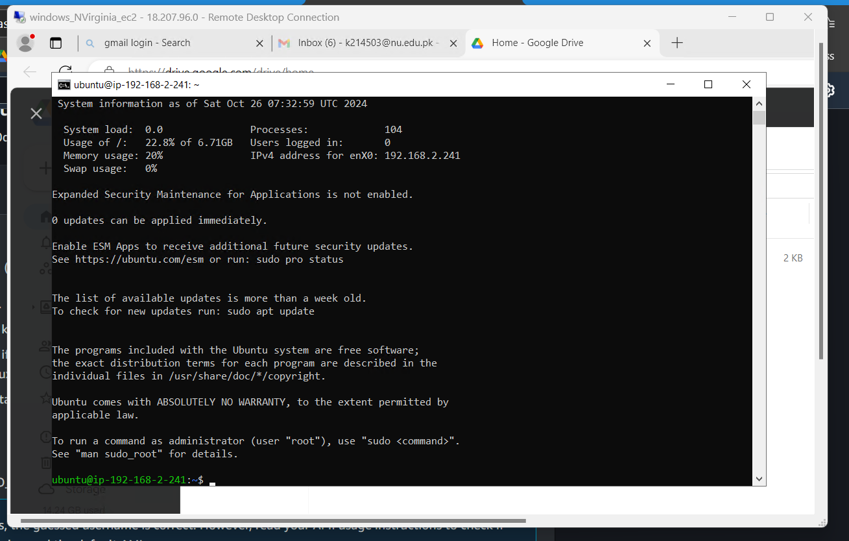

QUESTION 02

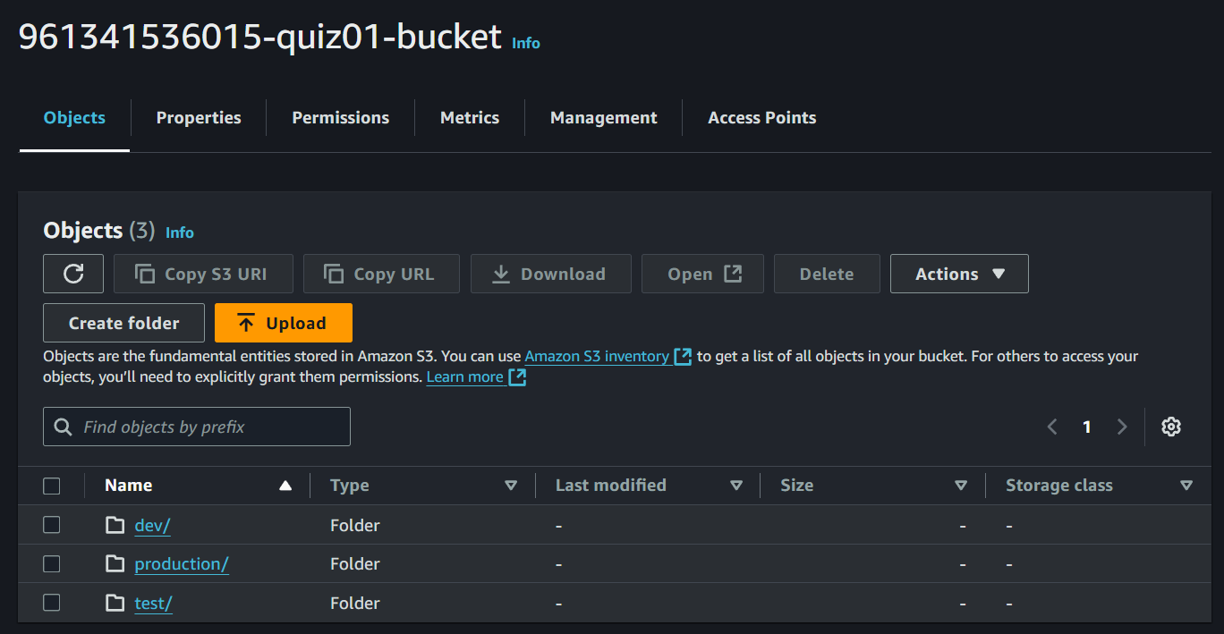

Users:

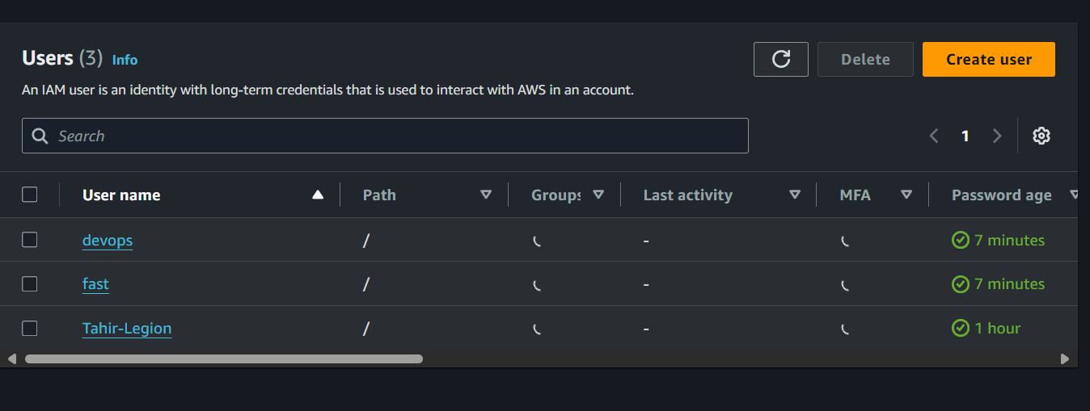

Policy:

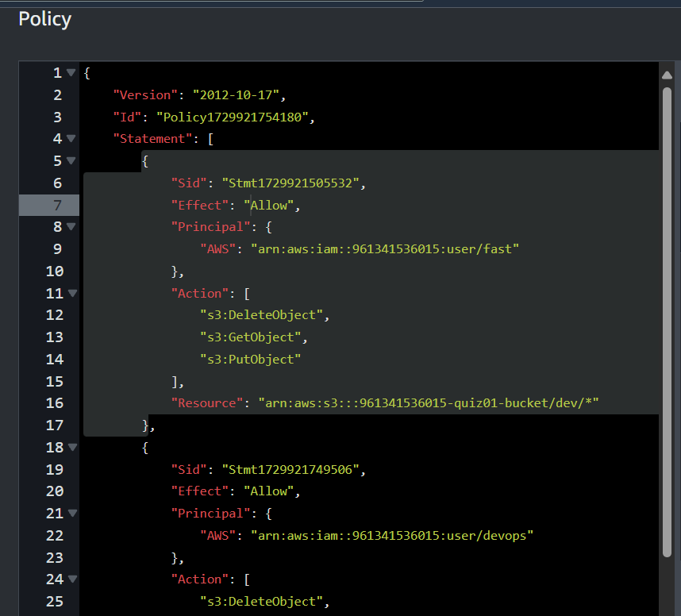

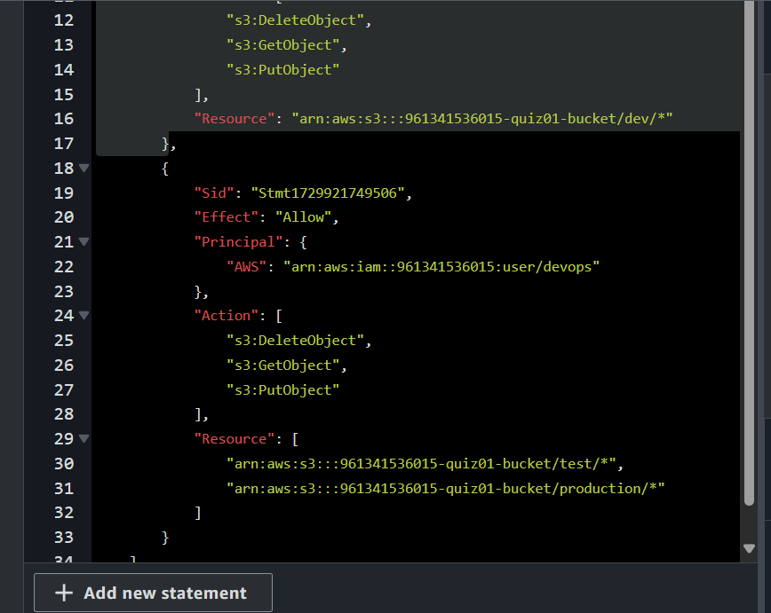

Complete policy:

{

"Version": "2012-10-17",

"Id": "Policy1729921754180",

"Statement": [

{

"Sid": "StmtAllowFastDevAccess",

"Effect": "Allow",

"Principal": {

"AWS": "arn:aws:iam::961341536015:user/fast"

},

"Action": [

"s3:DeleteObject",

"s3:GetObject",

"s3:PutObject"

],

"Resource": "arn:aws:s3:::961341536015-quiz01-bucket/dev/*"

},

{

"Sid": "StmtAllowDevOpsTestProductionAccess",

"Effect": "Allow",

"Principal": {

"AWS": "arn:aws:iam::961341536015:user/devops"

},

"Action": [

"s3:DeleteObject",

"s3:GetObject",

"s3:PutObject"

],

"Resource": [

"arn:aws:s3:::961341536015-quiz01-bucket/test/*",

"arn:aws:s3:::961341536015-quiz01-bucket/production/*"

]

},

{

"Sid": "StmtDenyFastTestProductionAccess",

"Effect": "Deny",

"Principal": {

"AWS": "arn:aws:iam::961341536015:user/fast"

},

"Action": [

"s3:DeleteObject",

"s3:GetObject",

"s3:PutObject"

],

"Resource": [

"arn:aws:s3:::961341536015-quiz01-bucket/test/*",

"arn:aws:s3:::961341536015-quiz01-bucket/production/*"

]

},

{

"Sid": "StmtDenyDevOpsDevAccess",

"Effect": "Deny",

"Principal": {

"AWS": "arn:aws:iam::961341536015:user/devops"

},

"Action": [

"s3:DeleteObject",

"s3:GetObject",

"s3:PutObject"

],

"Resource": "arn:aws:s3:::961341536015-quiz01-bucket/dev/*"

}

]

}